**Selling Widgets Online/University Depot**

**User Manual**

**Slippery Rock University**

Stephen Simpson - sjs1035@sru.edu

Cody Kuntz - cak1033@sru.edu

Heidi Bednarz - heb1010@sru.edu

Joshua Malone - jmm1067@sru.edu

Dustin Annarumo-dja1011@sru.edu

Zack Colich - zjc1006@sru.edu

Jenna Josselyn jmj1022@sru.edu

**General Manual**

Test Login Details

The application has login credentials for two different user accounts that can be used for testing. Both accounts can be used with the test database without having to go through the registration process. These accounts are accessed by inserting the provided information into the login page.

Regular User Account:

Username: userName

Password: testPass

Administrative User Account

Username: useradminwidget

Password: useradmin

Index Page

*Figure 1.a Index Page*

A: Prompt user to login – redirects to Home Page

B: Browse Button – currently does nothing

C: Sign Up – redirects to the user sign up form

D: Verify Email – Use this link to unlock a new account with the verification code sent to your email upon signing up

E: Mission Statement: - Displays the “company’s” mission statement

F: FAQ- Displays a page with common questions and answers

G: Work with us – This directs to a page where anyone can submit an online application

Sign Up Page

*Figure 1.b Sign Up Page*

A: A standard sign-up form. A username must contain at least 6 characters and be unique. Password must contain at least 8 characters 1 of which needs to be a special character such as (!@#$%)

B: This is a verification image called a CAPTCHA. The CAPTCHA will display a random series of letters/numbers and the user will need to copy them into the “CAPTCHA ANSWER” correctly

C: These (will) contain links to various informative pages, click on them to check them out.

Sign Up Page: The user must fill out the form completely to begin the user creation process. Upon completing this form and clicking the “add user” button the new user will be brought to the secret questions page which sets questions for the user to answer that can later be used in recovering a lost or forgotten password.

Sign Up Part 2: Secret Questions

*Figure 1.c Secret Question – Sign Up Part 2*

Select each secret question from the drop-down menus by clicking on the question prompts. Once you have answered all 3 questions the user creation process is over, and you will have received an email with the verification code to allow the account to get started.

Email Verification

*Figure 1.d Email Verification*

After a first sign up, the user is returned to the index page. On this page one simply needs to click the “Email Verification” button or “D” from *figure 1.a*. The user is prompted to type in their username and the verification code that was sent to their email address upon sign up. If the username and the verification code match then now the user is fully enabled to login.

Login Page

*Figure 1.e Login Page*

A: Redirects to form that will help a user recovery their username

B: Redirects to a form that will help a user recovery their password

C: Returns to the index page without doing a log on attempt

Login Page: The user must enter their username in the top field and password into the password field and then press the Sign In button to log on. If either are incorrect error messages will appear on screen. If one is having difficulty remembering their username or password use the links to start recovery.

The Home Page

Once you log in you will be brought to the home page – if your role is an employee you will be brough to the employee page. The home page has several buttons at the top which can lead you to different pages on the site. The User Account page allows you to view your account information, simply click on this button to view this page. The buttons below this are Create Widget, Logout, and Messages. Create Widget will allow you to make a posting on the site for you and other users to view. This will be covered in more detail in a later section. Logout will log you out of your current session and return you to the login index screen. Messages will take you to the messaging page to see messages from other users. This page will be covered in a later section. The home page is shown below in Figure 1.



*Figure . Home Page*

Searching

Below all of this is the search section of the home page. Here you can first select a category through the drop down menu or leave it on all to search all items. If you just hit search or the enter key right after selecting a category, you will see all the listings from that category.

*Figure . Selecting Category*

Next, put in a term for the search bar such as ‘computer’ or ‘truck’ just like in Figure 3 and if any listings have that in their names or descriptions as well as the category you selected, then they will appear in the search results page when you hit search or hit the enter key.

*Figure . Enter text to search*

You can also filter by price by selecting greater than or less than a certain price. Simply use the drop down menu that says greater than to choose ‘Greater Than’ or ‘Less Than’ and enter a dollar amount as shown in Figure 4. You can enter in USD by increments of 0.01. If you hit search or press the enter key after doing so it will display all listings with a price greater or less than the amount entered.

*Figure . Enter price to filter by*

Then when you hit search, it will take into account all of the parameters you set in the various options and show any listings that apply on the search result page as shown in Figure 5. This used the Electronics category, computer in the search bar, and greater than 50.02 as the price.

*Figure . Search Results*

Messages

*Figure 1.f Messages Page*

A: In this area we can compose a message to send to other users. The first text box you will enter the username of another account, the second is the subject – try to describe here what the message is about, the third text box is where you can type out the full message, and finally there is a send button – click this when you have filled out the above fields.

B: This button will send any highlighted message panes to the trash. You can highlight individual panes with “E” and all at once with “D” (NOT IMPLEMENTED YET).

C: This is where if you mouse over the subject in a message pane the pane will expand and turn blue and if you click a new page will display with the contents of the message.

D: (NOT DONE YET) This tick will highlight all of the message panes in red. Once highlighted you can deselect some or click “B” to send all of the red message panes to the trash.

E: Each of the individual ticks will highlight the message plane next to it in red. Any Panes that are red will be sent to the trash box if the button “B” is pressed.

F: This is a guide bar that sticks to the bottom of the page. It has buttons that will take you to each of the three mailboxes: the inbox, the outbox, and the trash. The trash will store your unwanted messages and after 30 days the messages will be completely removed from every one of your mailboxes. (A button will also be added to permanently delete a message)

User Account

The User Account page allows you to view the information for your account such as your Username, Display Name, Bio, and the date you joined. You can edit this information by clicking into the textboxes on the page and entering the new information. Then click the ‘Update Information’ button and it will take what you changed and update your profile with that information. There are some other buttons on this page that allow you to update payment and direct deposit details. Simply click on these buttons and enter the new information then click save.

*Figure : The user account page shows your basic account information*

Create Widget

To create a listing, first click the ‘Create Widget’ button on the home page. This will bring you to a page to select a category for your listing as shown in Figure 4. For now we are limited on the types of listings we can support so choose whatever is closest to the item you want to list then click next.

*Figure : Select the category your item best falls under*

Next you will be prompted to select a Sub Category, once again select the one closest to what you are selling and click next as shown in Figure 5.

*Figure : Select the sub category that is closest to your item*

You will then see a page with several text boxes, drop down menus, and buttons. Enter the information to the best of your ability such as the model of the item or the brand as shown in Figure 6. Then click next or hit enter.

*Figure : creating a computer*

Finally you will be asked to enter a price and quantity, simply enter this information and click the last button. This will create your listing and allow it to be searched.

Payment and Direct Deposit Information

Payment information is used to add the credit card that you will use to purchase items from the marketplace. Navigate to the “User Account” page as described in the User Account section. Press the “Update Payment Details” button as shown in the below figure.

*Figure - Accessing Update Payment Details*

This will open the “Update Payment Details Page,” shown in the below figure. The red “Cancel” button is used to return to the User Account page without making changes, while the blue “Update” button attempts to update your payment information. In order to successfully update your information, all of the fields in the form must be fully filled out, with valid information for a credit card.

*Figure - Update Payment Details Page*

**Buyer Manual**

Purchasing Items

Begin by following the instructions for the “Searching” section to get a list of listings that you can purchase from. Select a listing you would like to purchase from by selecting the “View Listing” link, as shown in the below figure.

*Figure - Search Results, Selecting Listing*

Opening the listing will present you with the webpage in the following figure. To attempt to purchase an item, you must fill out the “Number to Buy” form at the bottom, and then press the “Purchase Items” button. The number of item bought must be greater than 0, and it cannot exceed the number of items available for purchase.

*Figure - Purchase from Market Listing*

This will open the page for confirming your shipping address, as shown in the below figure. To continue your purchase, you must fill out the form with the shipping address, like is shown in the below picture, and then press the blue “Purchase” button. The purchase can also be cancelled using the red “Cancel” button.

*Figure - Confirm Shipping Address*

Once the shipping address is confirmed, the page for finalizing the purchase will be opened, and is shown with the below figure. From here, you can purchase either via credit card, which uses your existing payment information, or by submitting a Paypal purchase. You can select which purchase method to use by expanding either of the dropdown items highlighted in red. In either case, a form must be filled out with valid payment information, and then submitted in the same fashion as was done for the “Confirm Shipping Address” page.

Cancelling the purchase can be done by using the navigational bar alongside the top of the screen, or by pressing the red “Cancel” button that is shown when either of the dropdown menus are expanded.

*Figure - Confirm Purchase Purchase*

Viewing Purchases

Follow the instructions in the “The Home Page” section to reach the home page. The list of purchases you have made will be shown as in the below picture. To view information about a purchase, click the “Open Purchase” link, such as the one highlighted in red, that is associated with the purchase you would like to view.

*Figure 16 - Homepage, Opening Purchase*

This will open a page, like the one shown in the below figure, that shows all of the details of the purchase and its shipping information.

*Figure 17 - Purchase Information*

Viewing Shipping Status

Follow the steps described in the “Viewing Purchases” section to open the details of a purchase. The shipping address and shipping status are shown in the below figure, surrounded by the red circle.

*Figure 15 – Shipping Details*

**Seller Manual**

Creating a Market Listing

Follow the instructions under the “Create Widget” section. A Market Listing is created through this process.

Editing a Market Listing

As a seller, you can modify Market Listings that you have posted. Begin by following the instructions under the “Searching” section to find one of your widgets. From a successful search, select one of your Market Listings by pressing the “View Listing” button as highlighted below.

*Figure - Search to Edit Market Listing*

This will open a market listing view, as shown below. This page is like the page that is seen from the “Purchasing Items” section, but with the available actions changed. Within the top bubble shown on the diagram, there is a button to return to the homepage, and another button that removes the Market Listing. Within the bottom circle on the diagram is a form that you can use to change the price or number of items available for this listing.

*Figure - Edit Market Listing*

Viewing Sold Transactions

As a seller, you can view the list of transactions from buyers. To do this, begin by following the steps under the “The Home Page” section. This will show the page like the one in the following figure. Alongside the bottom of the page, there is a listing of transactions where you are the seller. This section can be seen in the following diagram, within the red oval.

*Figure - Home Page, Viewing Sold Transactions*

*Figure - Viewing Sold Transaction Details*

Adding Shipping Information

Follow the process to view your sold items. On the detailed page, there is a form at the bottom of the page that you can use to update the shipping information, which involves adding information on the carrier, as well as the shipping date and arrival date. Change these values and then press the submit button in order to add or update this information. The user will have already provided their shipping address to you while purchasing, which you can use while providing information to the carrier.

Employee Page

*Figure 1.g Employee Page*

A: This column will contain operational buttons that are dependent on the employee role.

B: This column displays the results of searches such as searching a user and then displaying all of the non-encrypted information in a table.

C: This last column will allow certain roles to make changes to the searched objects.

The employee page is the hub for the employees of this website. The admin role is the master controller and can see and do every task. The customer service and quality control roles have access to issues that users run into in the form of tickets. Tickets will contain a description of what occurred and the entities that were involved. The hiring agent can use the employee page to go over any of the applications that have been submitted to the website. Lastly, the sales role with have numerical data gathered from users, sellers, buys, etc. represented in various charts and tables for analysis and statistics.

Ticketing System - User Perspective

A: From the Normal user login-screen. The ticketing page will appear on the navigation bar to the left.

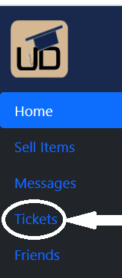

*Figure - Ticketing Navigation Bar*  
A: From the Normal user login-screen. The ticketing page will appear on the navigation bar to the left.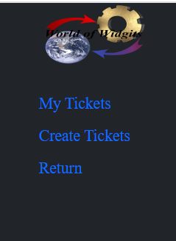

*Figure - Ticketing Nav Bar options*

B: The user is now able to view the tickets he has created in the “My Tickets” option, Create a new ticket in the “Create Ticket” option, or return to the homepage with the “Return” option.

*Figure - User Creation of a Ticket*

C. If the “Create Ticket” option is selected, the user may now create a ticket. This will allow a subject and description to be filled out for the admin roles to view from their separate log-in. Cancelling the ticket will take the user back to the “Create Ticket” page, while the Create Ticket button fill create a ticket in the system. 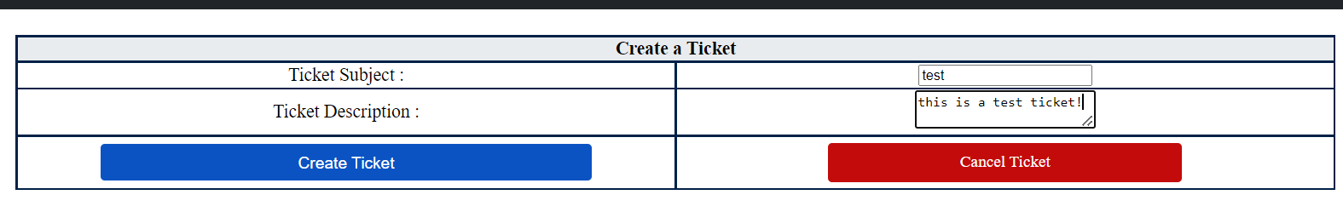

*Figure - My Tickets information*

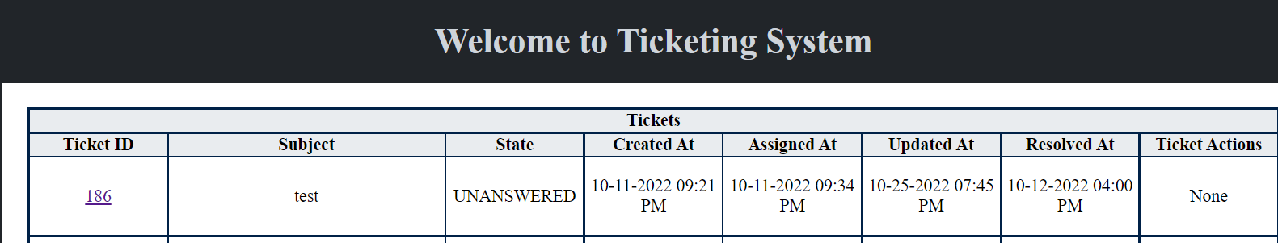

D. If the ticket is created, you will be taken to the My Tickets page that shows various details about the ticket. An ID is created for the ticket, along with the Subject that the user had previously created. The “State” of the ticket shows whether a ticket has been either “UNASSIGNED”, “UNANSWERED”, or “RESOLVED” depending on the admin’s progression of the ticket. This ticket information also includes when the ticket was created, when the ticket was assigned, the last time the ticket was updated, and when the ticket was resolved. The “Ticket Actions” may include the ability to re-open a closed ticket as seen in the “Resolved Ticket Example”, only if the ticket’s State is already resolved.



*Figure - Resolved Ticket Example*

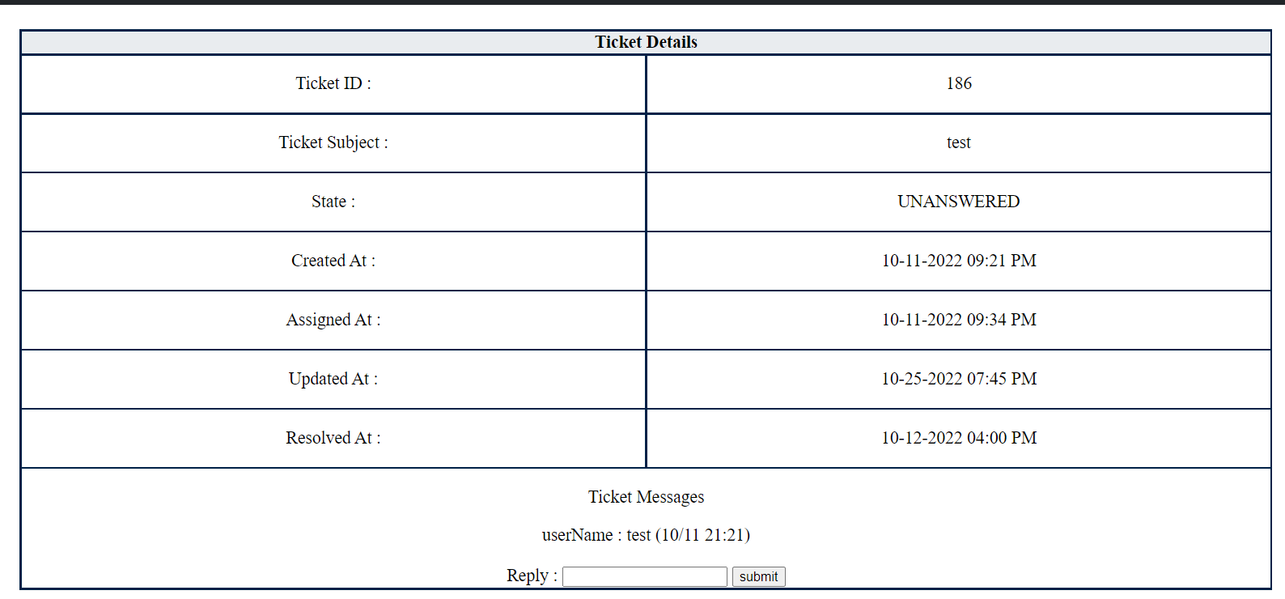

*Figure - Ticketing Details*

E. As you can see in *Figure - My Tickets information,* The ID of the ticket also functions as a hyperlink to the Ticketing Details page. This page shows the same information as before in larger and more readable scale, but most importantly features a messaging system between the user, and to the admin role that is assigned to the ticket. Typing a message into the Reply box, and hitting the submit option, allows the admin role who is assigned to the ticket to message and interact with the user of the ticket. The admin role assigned to the ticket is also able to reply to the messages, which the user can also see in this page.

Ticketing System - Admin Perspective

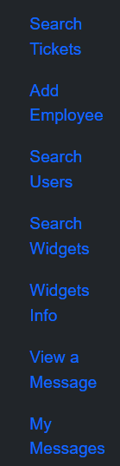

*Figure - Admin Navigation Bar*

A. After logging into the Admin account, you can select the “Search Tickets” Option as seen in the *Figure - Admin Navigation Bar*  This will take you to the list of tickets that have been created by any user.

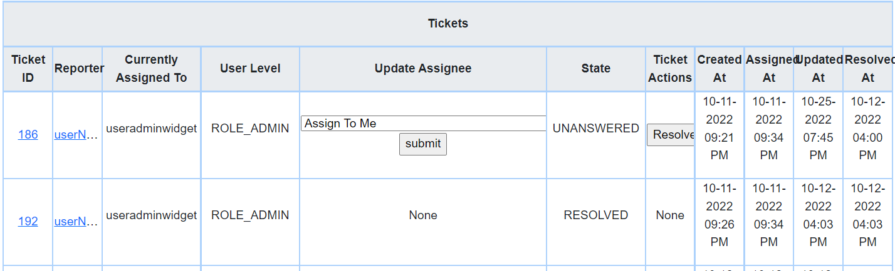

*Figure - Admin My Tickets*

B. Once “Search Tickets” has been selected from the navigation bar, all of the tickets created by users is shown. This page shows a few more details, such as the user who reported the ticket, the level of the ticket, which is determined by the role of the administrator that the ticket was assigned to. Updating the Assignee will update who the ticket is being controlled by. Only the Assignee is able to reply to tickets, as well as resolve them. There are various roles that have been created that the admin can assign the ticket to, to the best of their ability considering the subject matter. Furthermore, the Ticket Actions includes as Resolve button, but again only if you are logged in as the account that the ticket has been assigned to. As seen in *Figure - Admin My Tickets,* I am able to resolve the ticket because it has been self-assigned to the test admin account. Lastly updating the assignee, sending a message to the user, or resolving the ticket will send an email to the user’s associated email address about the update that has been made to their ticket.

. *Figure - Update Ticket Assignee*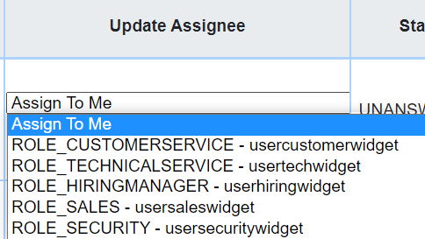

C. Also, as seen in the *Figure - Admin My Tickets,*  the reporter of the ticket is also included as a hyperlink, which directs you to the “Search User” page, allowing you to search the user that has submitted the ticket, and directing you to the information available in the “Search User” page.

D.. Lastly, as shown in *Figure - Admin My Tickets,* the ID of the ticket is again used as a hyperlink, which takes you to the Admin Ticket Details Page, shown below. This is where the details of the ticket are shown, but now the admin that is associated with the ticket may respond to the messages sent to the user.

*Figure - Admin Ticket Details Page*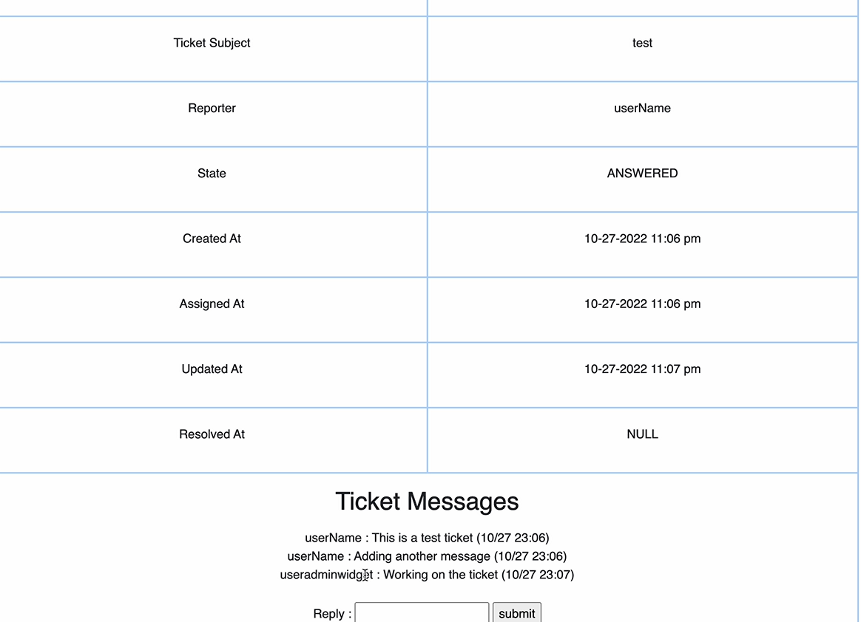

Create Widget Info - User Perspective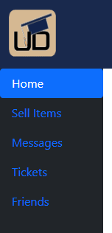

*Figure - User Navigation Bar*

A.To sell a widget, select on the “Sell Items” Option, seen here in *Figure - User Navigation Bar*

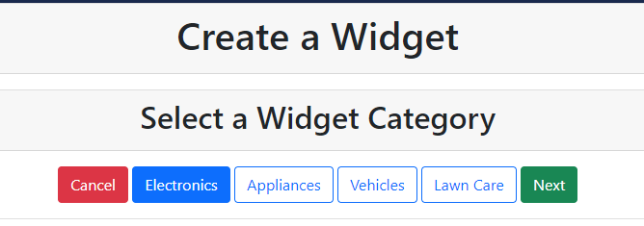

*Figure - Create Widgets*

B. After you arrive on the Create Widget Page, you must select a category as well as sub-category of item.

*Figure - Create Widgets Details*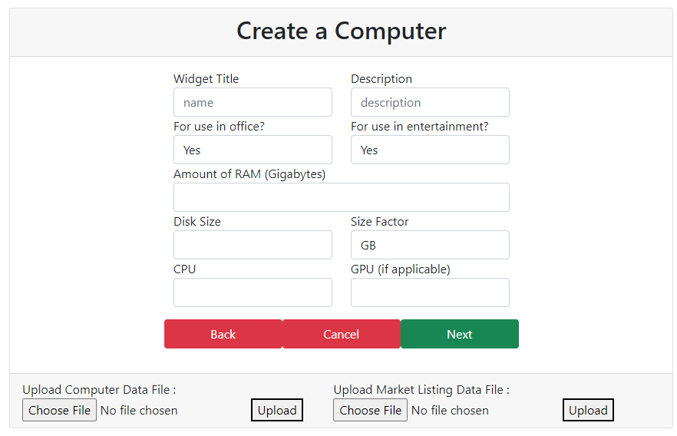

C. Now you are the creation of the specific widget. You may enter the information as desired, or use the upload options below to help ease of creation. So, there are two separate upload files that exist. One is for Widget data itself and the other is for market listing. The widget id alone needs to pulled or edited after creating widget and should be entered in the corresponding row in marketlisting file that is being uploaded.

Widget Info - Admin Perspective

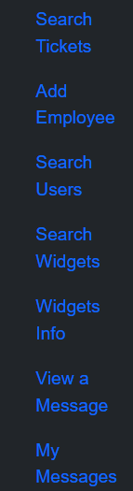

*Figure - Admin Navigation Bar*

A. To Access the widgets information, select the “Widgets Info” from the *Figure - Admin Navigation Bar,* seen here.

*Figure - Widgets Info Homepage*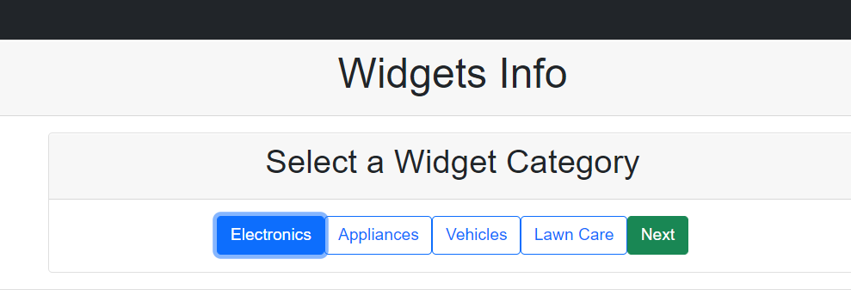

A. Once Selected, you can select the type of widget you’d like to adjust, after hitting the “Next” button, it may take you to a sub-category page, where you can selected the subcategory to adjust.

*Figure - Widgets Category Details*

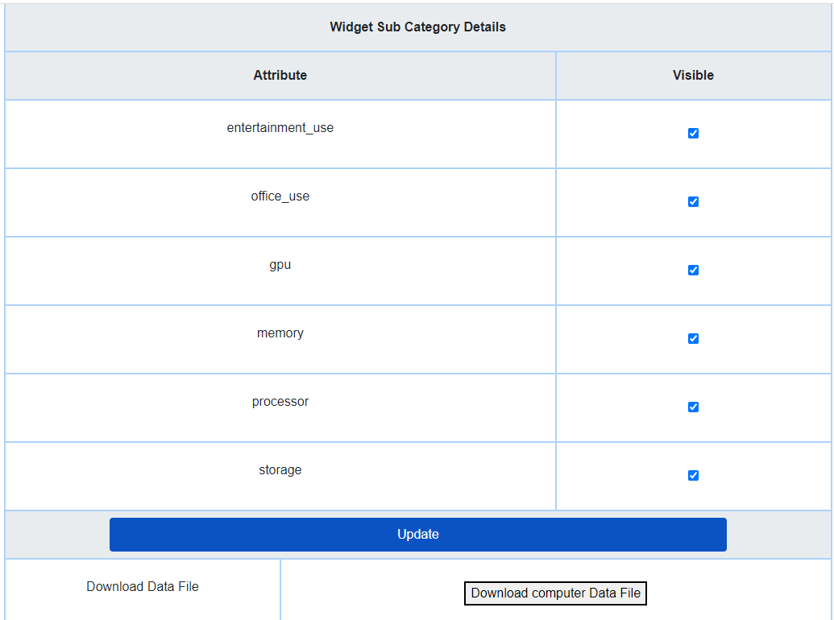

B. Once a category and subcategory are selected, the admin may select and deselect the checkboxes as seen in *Figure - Widgets Category Details,*  Once the checkboxes are selected and de-selected as desired, hitting the Update button at the bottom of the screen will update what attributes are to be made visibles. (As Default the checkboxes are set to true/visible)

C. The Download button also in *Figure - Widgets Category Details* (greyed out currently), allows you to download the existing data into an excel sheet. This allows the admin to edit the excel sheet directly with the attributes for a new product in the sub category, rather than creating a new excel sheet which may be prone to errors. (heading etc)